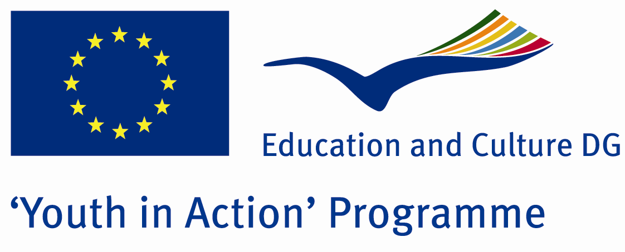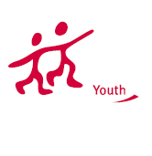

Action 1.1
Project Summary; We are student group from Amasya. Our city is North of Turkey. Everybody knows that there is thebiggest problem of european union is economic crises. We wantto do discussion about it and improvingsolutios with locale conomicun it.If you interest economy just join to us!
Project Title; Youth solutions about economic problems of europe
Date and Venue ; 07-14 August Turkey
Place: Amasya.

Target Group ; Municipalities, City Councils and Non-Governmental organizations,
youth groups,culture and art groups,e.t.c

Participants ; 5 people from each country (over 18 -25 ). Totally 8 countries.

Conditions ; Accommodation, board and programme costs will be financed through European Commission Youth in Action Programme . Travel costs will be reimbursed in 70% (APEX Tarrifs). Organizations from all 27 EU member countries plus Liechtenstein , Norway and Iceland are eligible to take part.

Working language: English

Organisator group: Group Synergy

How to apply: If you are interested, please send your Part III forms to
by e-mail please (in word file). Scan Part3 format is enough for application.(Fulfilled Part III which you can find in the attachment, of course signed and stamped) ..

Contact e-mail:groupsynergyturkey@gmail.com

